CV200 BARCHECK

(note MKIII may use standard checks)

-If not already done , on the Chip Icon open Hypack ini 3102_ETCV200_VB.ini.

Go to setup on the Odom device and de-select channel 2. save this as

3102_ETCV200_VB_Barcheck.ini. Save Survey32, Save Project.

Have Personnel ready in place with barcheck. Have form ready. Instruct them to place the marks on the rail RP. An alternative is to record the mark on waterline, be specific and record bubble reading in either case.

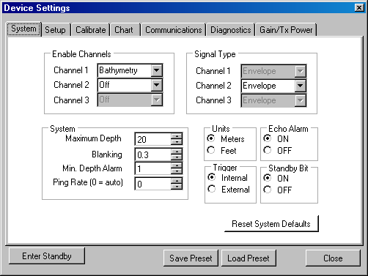Open E-chart program. In setup deselct channel 2 bathemety to off.

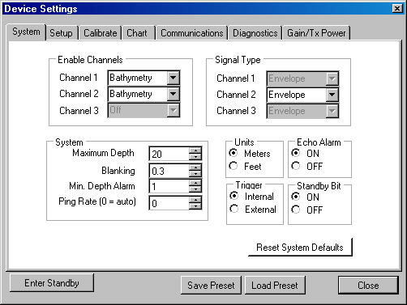

Run Hypack Survey

Start logging data

Click on Bar check. The Odom uses a dynamic gate, the bar check program turns this off for user intervention.

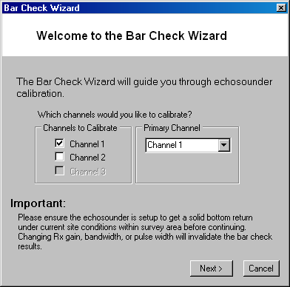

Only channel 1

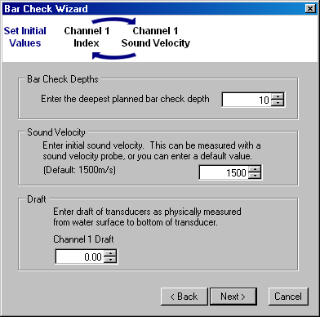

Set Max depth to 10m (20 if you need more) but watch bottom go to next menu

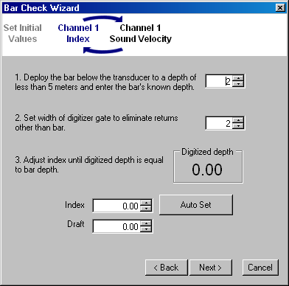

Each Reading set level as below maintain gate at2

Set at 2 On theRP on Rail place bar at 3

Set at 3 On theRP on Rail place bar at 43 REP on rail

Lower bar to each level at the yellow VB refpoint on the port rubrail . Read depth display and record time, depth and bar reading.

You will always be one off on the setting option 2. This creates a 2m gate around the bar.

Lower and raise in this manner 2,4,5,6,7 6, 5,4,3,2. You need to align option 1 each time it is lowered and raised. If you don’t get a reading record as N/A. It is usually one less than the bar.

Depending on conditions you may be able to go deeper.

After you are complete hit Cancel on the BAR screen. Stop Logging.We don’t want to go into further calibration.

**RESET Odom to DUAL operation Both Channels. Use Normal Hypack INI’s Dual channels**

7125 BAR CHECK

The 7125 is simpler. Log Hypack hsx data

Have Personnel ready in place with barcheck. Have form ready. Instruct them to place the marks on the rail RP. An alternative is to record the mark on waterline, be specific and record bubble reading in either case.

Turn Gates Off

Lower bar to each level at the yellow VB refpoint on the port rubrail . Read depth display and record time, depth and bar reading.

Lower and raise in this manner 2,4,5,6,7 6, 5,4,3,2. If you don’t get a reading record as N/A.

After Complete Stop logging. Turn gates back on.

